Assignment-IV

Ashok Kaushik
19BCS059

- Pull an Image from docker hub and run it in docker playground.
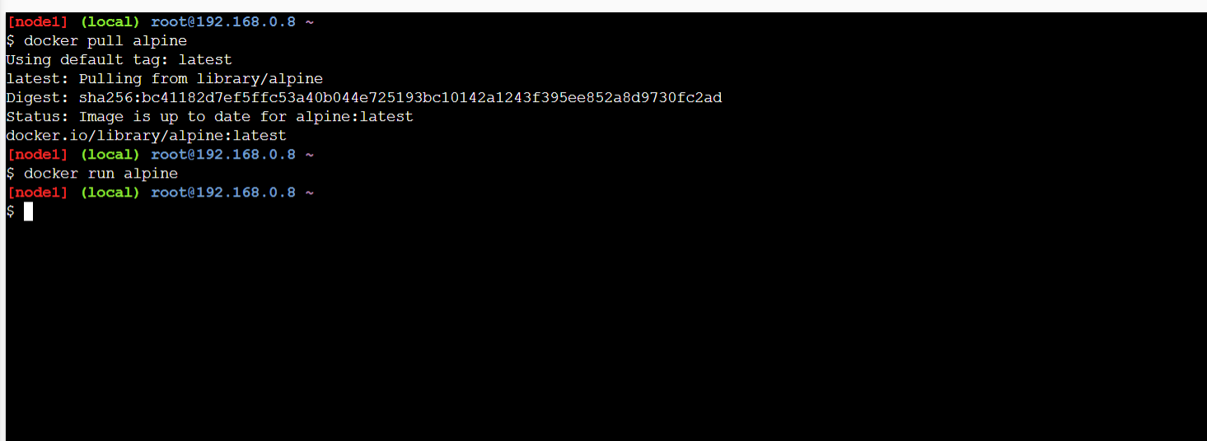

2. Create a docker file for the hello world application and deploy it in Docker desktop application.
Building the image from the file: docker build -t helloworld:0.1 .
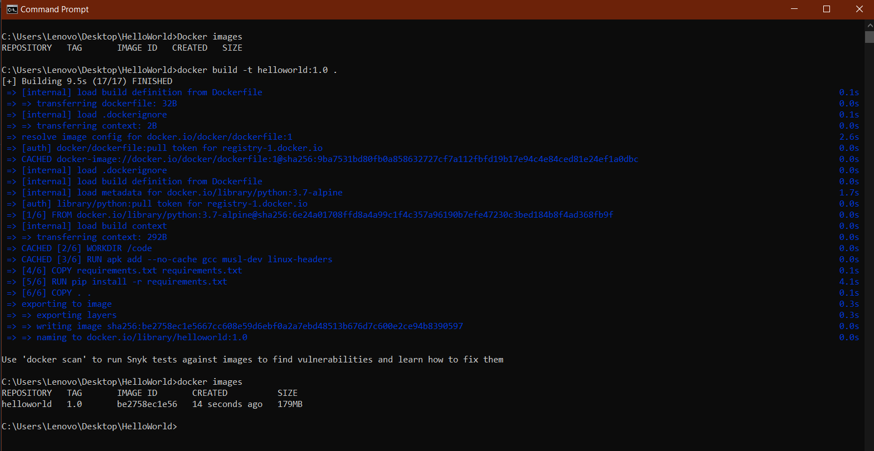

Docker desktop app:

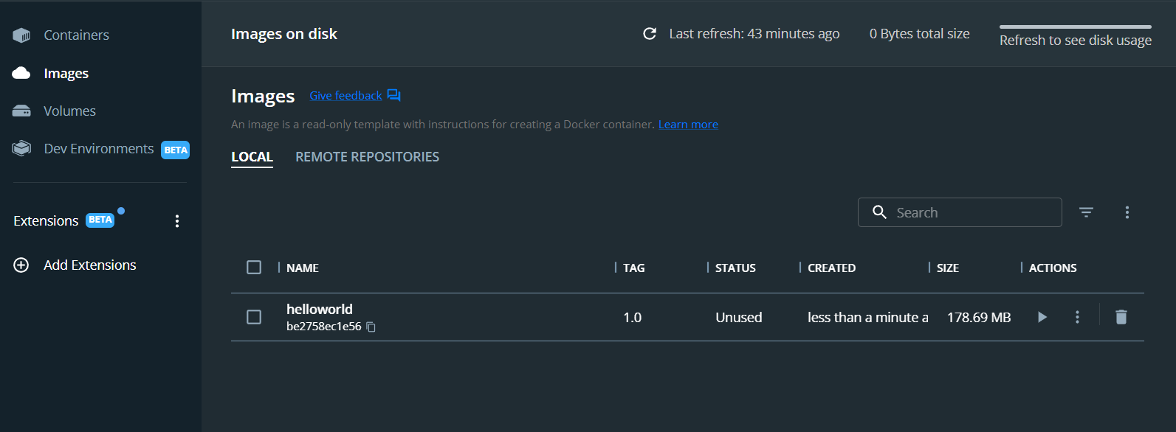

Run the container:
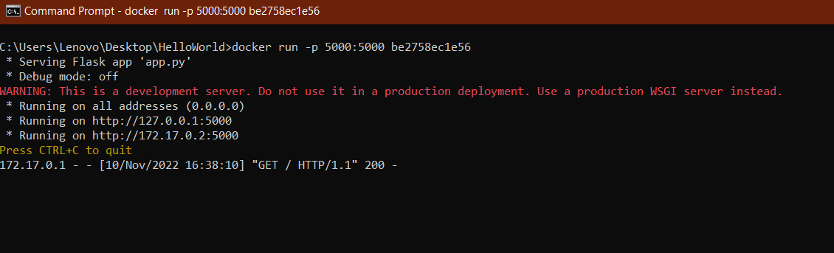

Output:
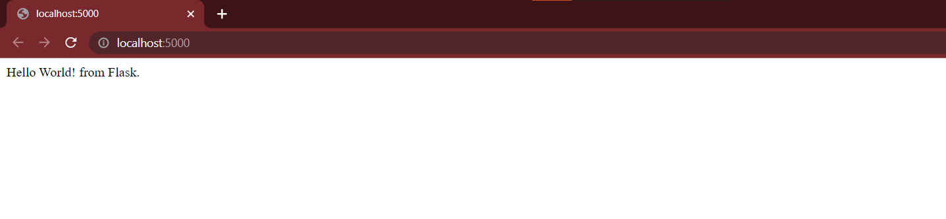

3. Create a IBM container registry and deploy helloworld app.

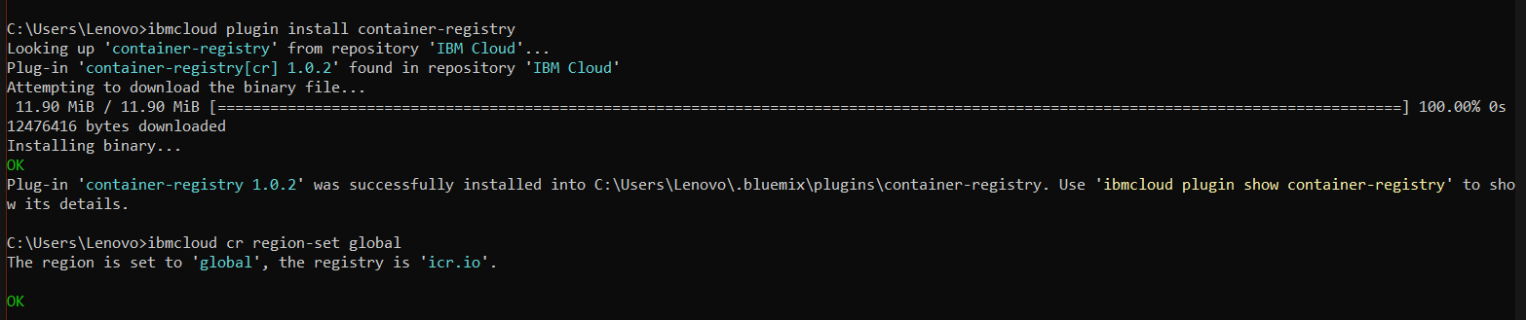

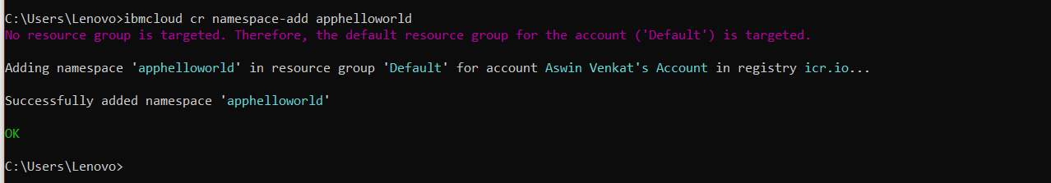

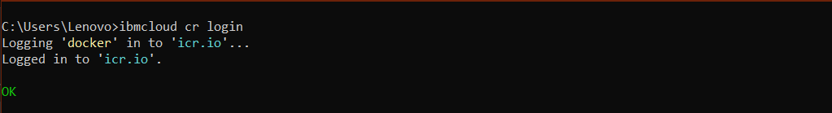

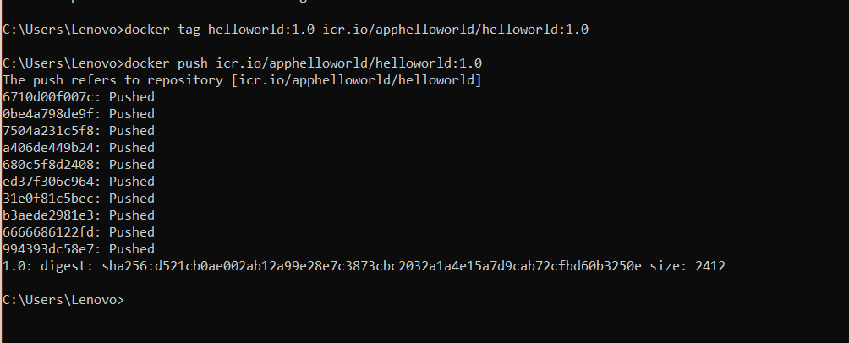

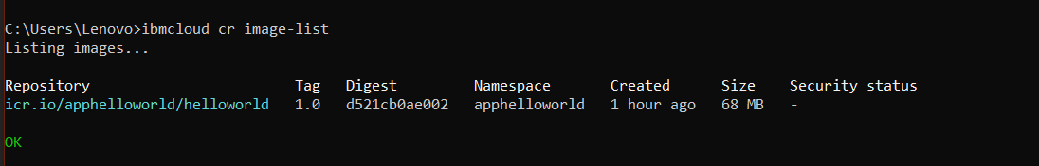

The image is pushed to the namespace.
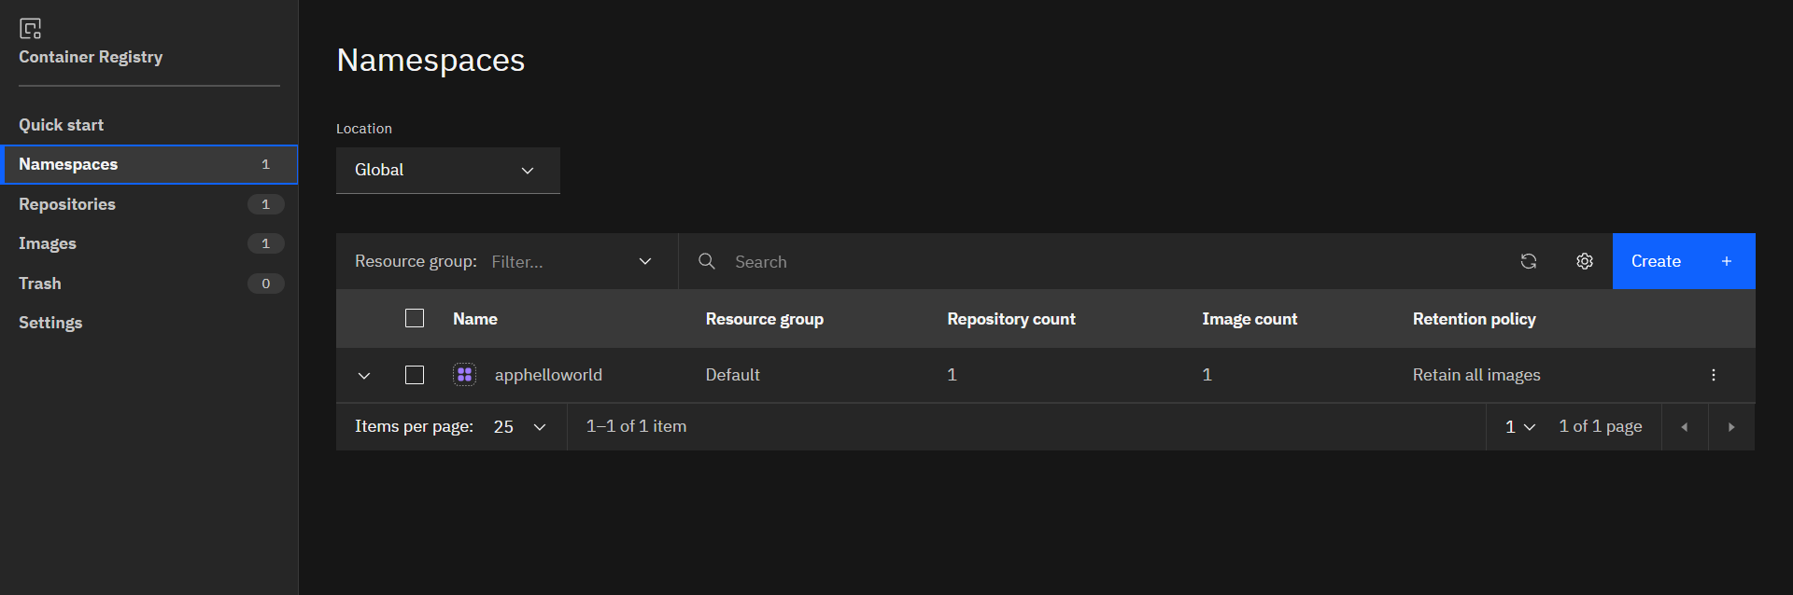

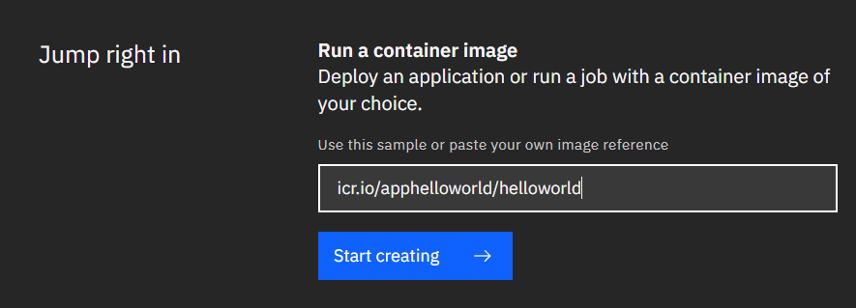

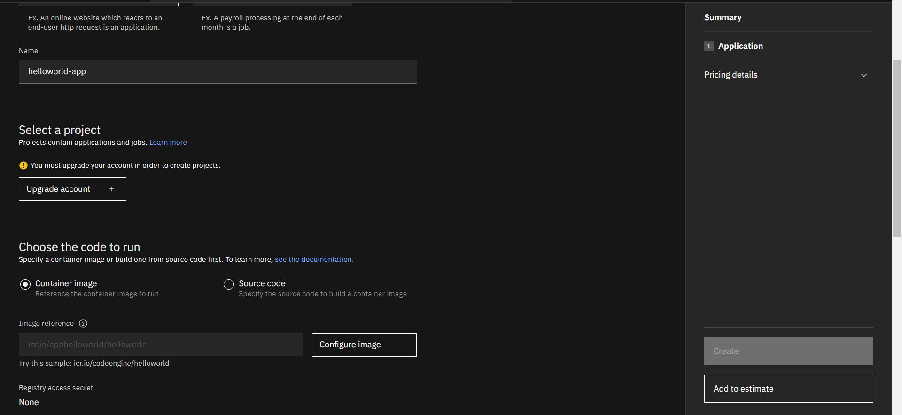

4. Create a Kubernetes cluster in IBM cloud and deploy helloworld image and also expose the same app to run in nodeport.
Cluster:
